

**LAB-02**

**Title: Use of Conditional Operator in SQL.**

**Name: Azizul Abedin Azmi**

**ID: 2022-1-60-130**

**Section: 02**

**Course Code: CSE302**

**Course Title: (Database Management System)**

**Date: 13/07/2024**

**Course Instructor:**

**Dr. Mohammad Arifuzzaman**

**Associate Professor**

**Department of Computer Science and Engineering**

**Task-1:**

CREATE TABLE Student_info (

    Stu_id INT PRIMARY KEY,

    Stu_name VARCHAR(50),

    Stu_address VARCHAR(100),

    Course_id VARCHAR(10)

);

INSERT INTO Student_info (Stu_id, Stu_name, Stu_address, Course_id) VALUES

(401, 'Asif', 'Dhaka', 'CSE-246'),

(406, 'Ana', 'Sylhet', 'CSE-103'),

(403, 'Bobi', 'Rajshahi', 'CSE-405'),

(402, 'Rupa', 'Dhaka', 'CSE-246'),

(405, 'Riya', 'Dhaka', 'CSE-405'),

(407, 'Robi', 'Khulna', 'CSE-302'),

(408, 'Nazrul', 'Khulna', 'CSE-302'),

(404, 'Ovi', 'Barisal', 'CSE-103');

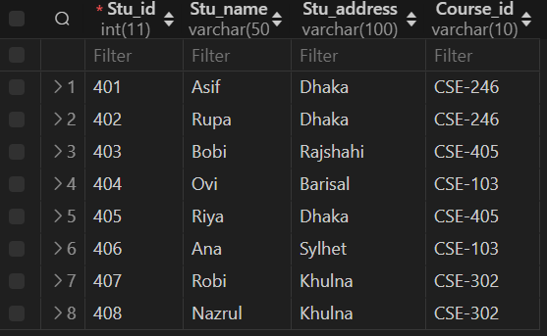

CREATE TABLE Course_info (

    Course_id VARCHAR(10) PRIMARY KEY,

    Course_name VARCHAR(50),

    Semester VARCHAR(20),

    Year VARCHAR(10)

);

INSERT INTO Course_info (Course_id, Course_name, Semester, Year) VALUES

('CSE-103', 'Programming', 'Fall', '2022'),

('CSE-302', 'Database', 'Spring', '2023'),

('CSE-246', 'Algorithm', 'Fall', '2021'),

('CSE-405', 'Networking', 'Summer', '2022');

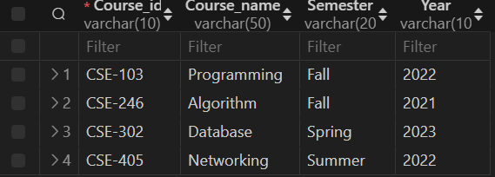

CREATE TABLE Workers (

    ename VARCHAR(50),

    Cname VARCHAR(50),

    salary INT

);

INSERT INTO Workers (ename, Cname, salary) VALUES

('Rahim', 'Samsung', 20000),

('Sabbir', 'GP', 30000),

('Mitu', 'Robi', 15000),

('Toma', 'Ericson', 35000),

('Jabber', 'Samsung', 60000),

('Babu', 'Robi', 25000);

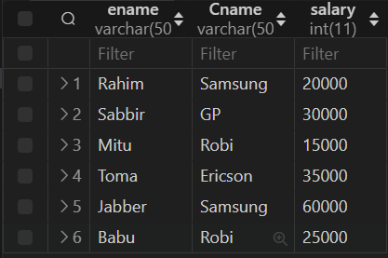

**Task-2:**

SELECT * FROM Course_info

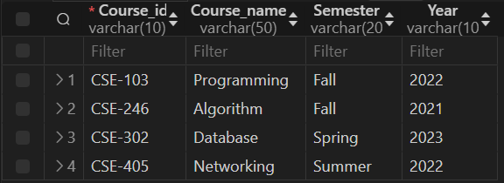

**Task-3:**

SELECT Stu_name FROM Student_info

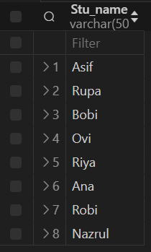

**Task-4:**

SELECT Course_id, year FROM Course_info

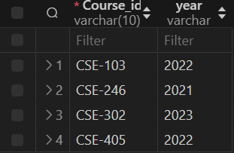

**Task-5:**

SELECT * FROM Student_info where Stu_name='Rupa'

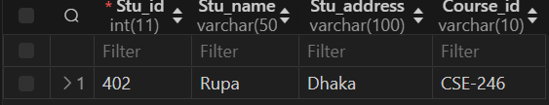

**Task-6:**

SELECT Course_name,year FROM Course_info where year < 2023 and semester='Fall'

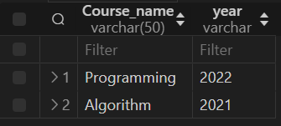

**Task-8:**

SELECT stu_name FROM Student_info WHERE stu_id BETWEEN 404 and 408

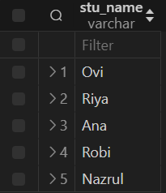

**Task-9:**

SELECT * FROM Student_info WHERE stu_address IN ('Dhaka','Khulna');

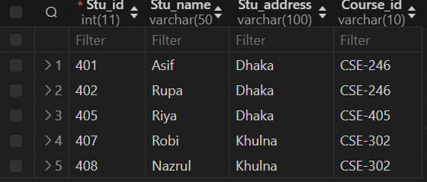

**Exercise-1:**

SELECT ename FROM workers WHERE `Cname`= 'Samsung';

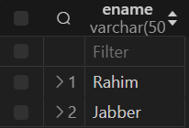

**Exercise-2:**

SELECT ename FROM workers WHERE salary < '25000';



**Exercise-3:**

Using Between:

SELECT ename, Cname, salary FROM Workers WHERE salary BETWEEN 25001 AND 50000;

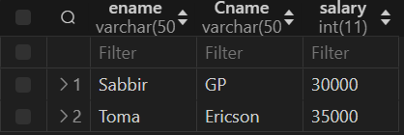

Using Between:

SELECT ename FROM workers WHERE `Cname`= 'Samsung';



**Exercise-4:**

SELECT Stu_id, Stu_name, Stu_address, Course_id FROM student_info WHERE Stu_address != 'Dhaka';

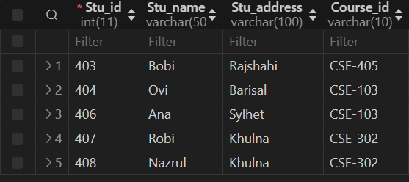

**Exercise-5:**

SELECT ename, Cname FROM workers WHERE salary < 20000 AND Cname = 'Robi';

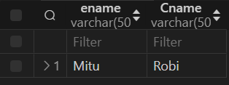

**Exercise-6:**

SELECT Stu_id, Stu_name, Stu_address FROM student_info WHERE Course_id = 'CSE-302';

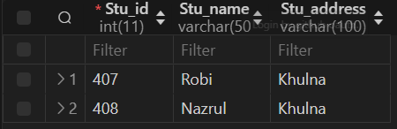

**Exercise-7:**

SELECT Course_id, Course_name, Semester, Year FROM course_info WHERE Semester = 'Spring';

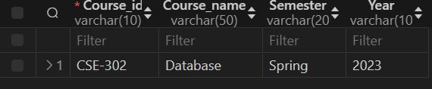

**Conclusion:**

From the above information and exercises, we can conclude the following:

* SQL commands such as SELECT, WHERE, IN, BETWEEN, and <> (not equal) were used effectively to retrieve specific data from tables.
* Conditional operators (=, <>, >, <, >=, <=, BETWEEN, IN) were applied to filter records based on specified conditions.
* Tables (Student_info, Course_info, Workers) were created, and data was inserted into them using CREATE TABLE and INSERT INTO statements.
* Each task and exercise provided a hands-on experience with SQL queries to manipulate and extract data as per given requirements.